Green Group
Alexander Baldree
Jordan Dardar
Maksymilian Jankowski
Aftabur Rahman
12/9/25
CSD310 Milestone #3
GitHub Link:
https://github.com/Panda-Alex21687/Green-Group

Report 1: Equipment Older Than 5 Years
One of the main questions from the owners is whether any equipment is older than five years, since old gear can be unsafe and costly to maintain. This report checks every item in inventory and compares the acquisition date to today’s date. Anything older than five years should be reviewed for replacement. This helps the inventory manager decide what items need to be retired or reordered.

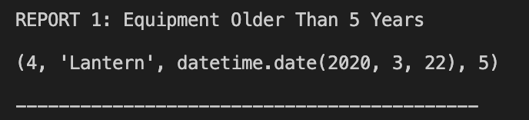

Report 2: Booking Trends by Region

The owners also want to know if any regions; Africa, Asia, or Southern Europe; are losing popularity. This report counts all customer bookings grouped by region. By comparing total bookings per region, the company can see if any area is trending downward, which helps them decide whether to adjust marketing strategies or cancel underperforming trips.

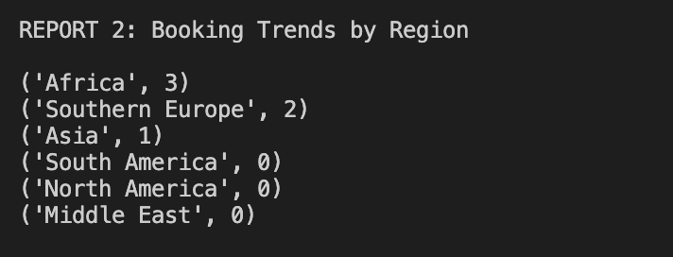
Report 3: Sales vs Rental Revenue

Outland Adventures wants to know if selling equipment is worth continuing or if rentals bring in more revenue. This report totals all revenue from sales and rentals based on order type. By comparing sales income vs rental income, the owners can determine whether equipment sales should be expanded, reduced, or removed from the business model.

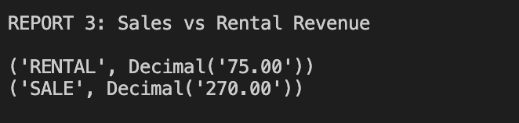

Report 4: Guided Assignment Report
The owners also want to understand how trip responsibilities are distributed among their guides. This report counts the total number of trips assigned to each guide. By reviewing how many trips each guide is responsible for, Outland Adventures can determine whether workloads are balanced or if one guide is being overused. This information helps the owners decide if trip assignments need to be adjusted or if additional guides should be hired as the business continues to grow.
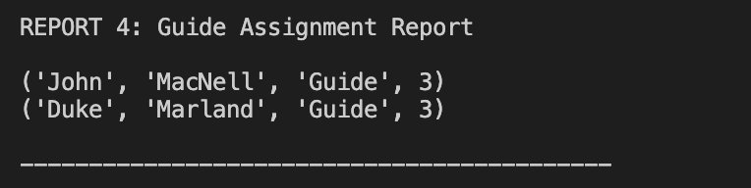

Report 5: Equipment Order Frequency
The owners want to evaluate how often different pieces of equipment are being rented or sold. This report summarizes equipment order activity by item and order type (sale or rental), along with the total revenue generated. By analyzing which items are ordered most frequently and whether sales or rentals are more profitable, Outland Adventures can make better inventory decisions, such as stocking more popular items or reconsidering equipment that does not generate enough demand.
